| **NAME** | Pratheek.P.Rqo |
| --- | --- |
| **REG NO** | 311520104036 |
| **CLASS** | B. E - CSE |
| **EMAIL ID** | pratheekprao@gmail.com |
|  | **ASSIGNMENT - 3** |

| **Task** | Perform the three types of Visualization |
| --- | --- |
| **Problem Statement:-** | |

**Tasks:-**

1. Download the dataset: Dataset
2. Load the dataset.
3. Perform the Below Visualizations.
   * Univariate Analysis
   * Bi - Variate Analysis
   * Multi-Variate Analysis
4. Perform descriptive statistics on the dataset.
5. Handle the Missing values.

**Univariate Analysis**

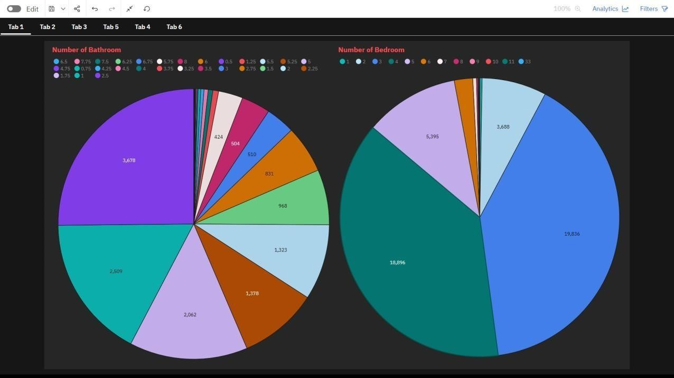

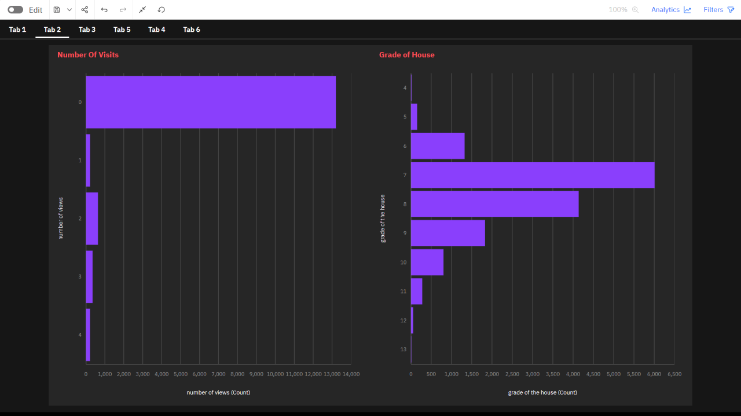

**Bi-variate Analysis**

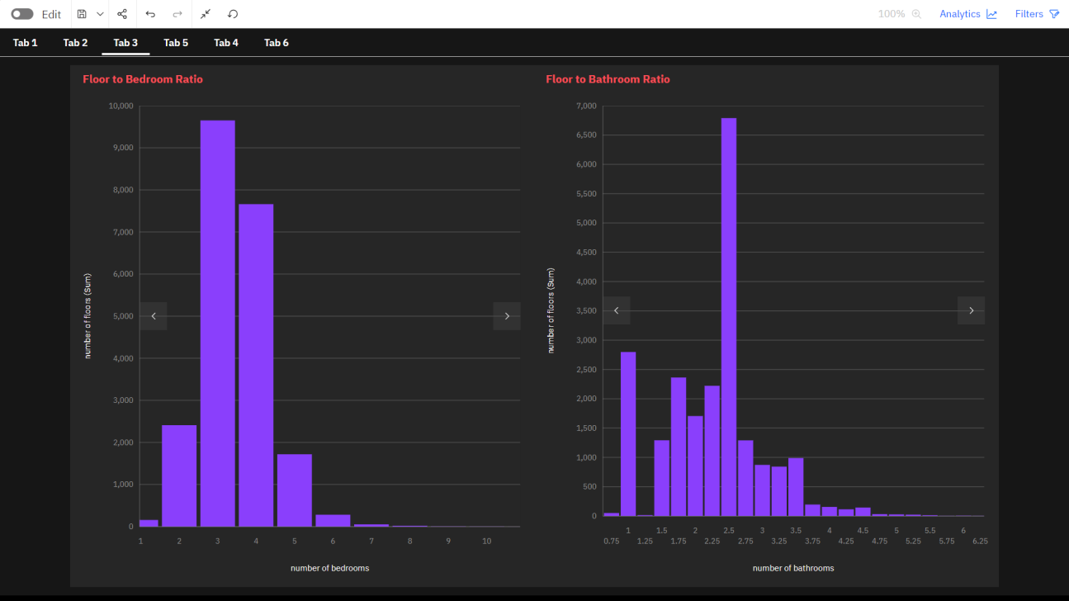

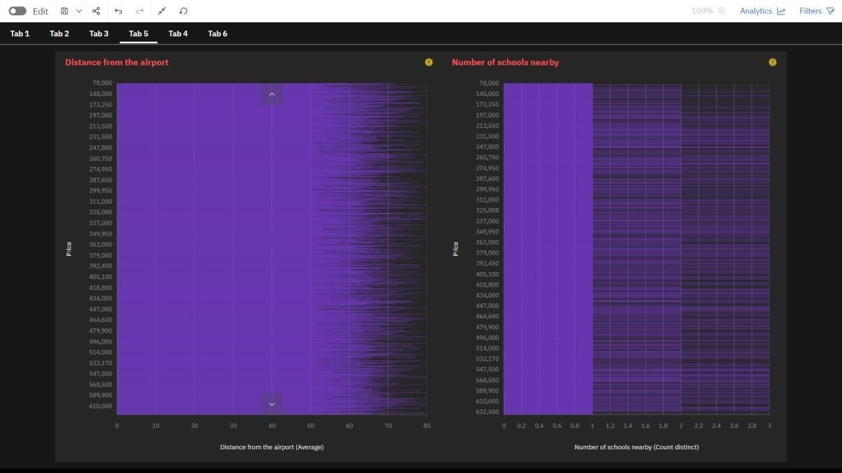

**Multi variate Analysis**

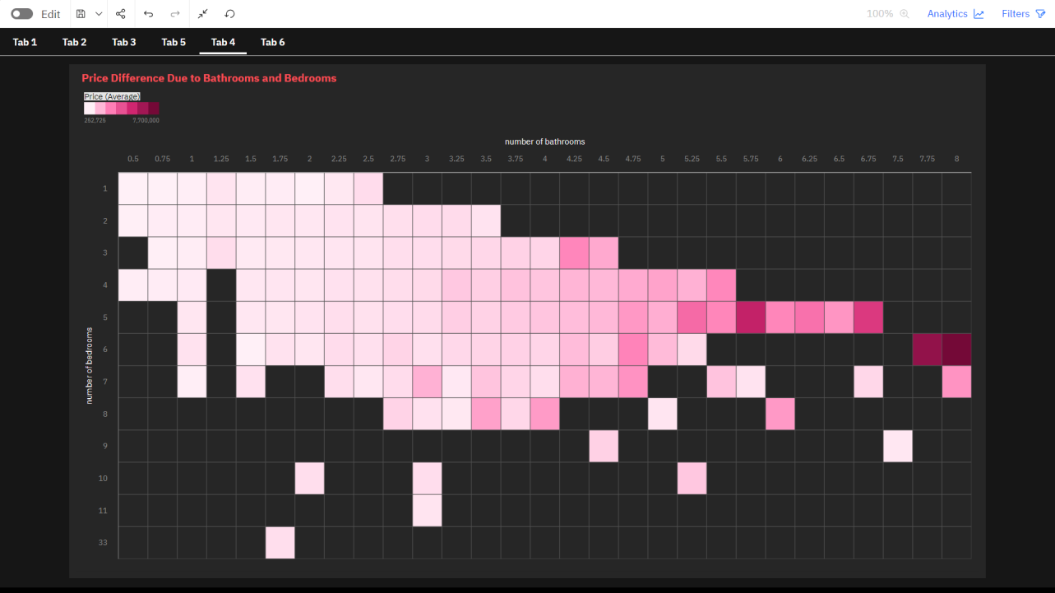

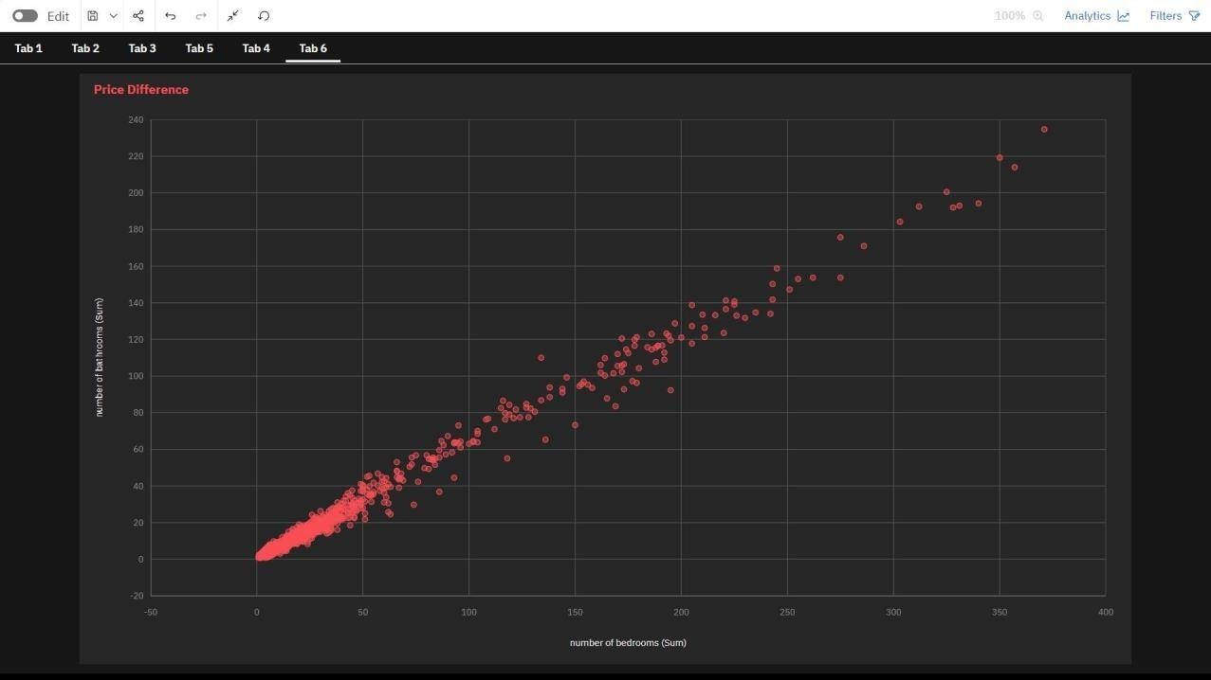

**Perform descriptive statistics on the dataset**

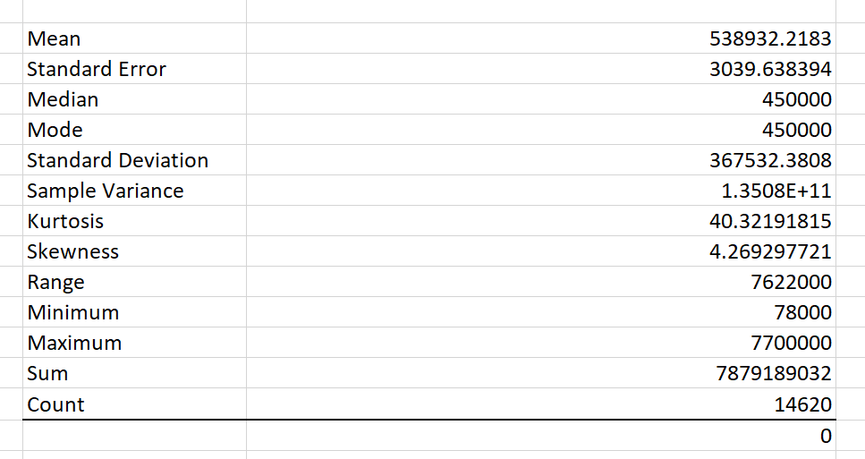

**Handle the Missing values**

**No Missing values in the Data set.**